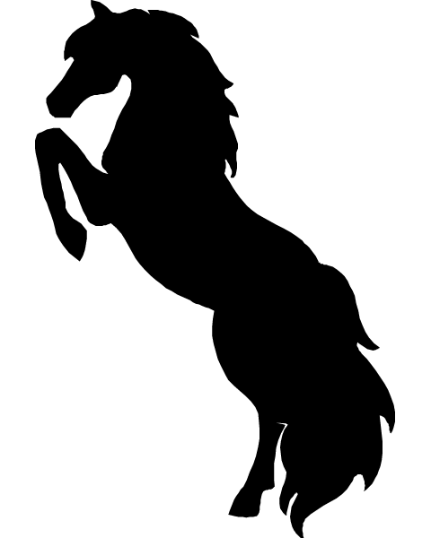
Barn Rules
- Absolutely NO SMOKING in barn, smoking outside of barn permitted only if butts are not thrown on ground.
- No alcohol on premises.
- Stay off areas of grass, lawn, hay field, etc… Do not leave holes/divots anywhere.
- No riding after dusk.
- No property is to be removed from barn. Theft will not be tolerated.
- Barn hours are seasonally different based on daylight.
- Pick up any manure/hair and put in wheel barrow or manure spreader.
- Put everything back where you found it, do not leave anything in hallway or outside.
- Do not tie horses in different paddocks close to one another without permission.
- If you use the last of something, notify barn owner.
- If any damage is done to equipment notify barn owner.
- No riding In barn.
- Throw all garbage in garbage cans.
- Equestrian safe helmets are required for anyone under the age of 18, unless a release form is signed by a parent or guardian.
- Wear appropriate barn/riding attire.
- Do not give horse additional grain/feed without permission.
- Be respectful to others on trails and in arena.
- Inhumane treatment of animals will not be tolerated.
- No unauthorized guests allowed.
Rules are subject to change. If you have any questions please ask barn owner.
George, Sandy & Breana Wynkoop
Home- 845-246-2111
Cell- 845-399-1764

